Question 1

1.This code is saved in q1.py

2.Write a Python class, Flower, that has three instance variables of type str, int, and float, that respectively represent the name of the flower, its number of petals, and its price. My class must include an initializer that initializes each variable to an appropriate value, and my class should include methods for setting the value of each type, and retrieving the value of each type. My program should be robust enough to handle possible inappropriate inputs.

3.Execute as followings:

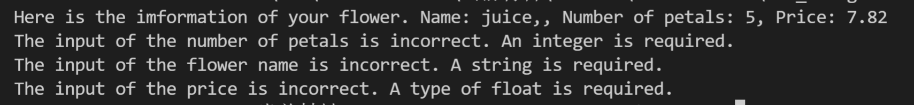

Question 2

1.This code is saved in q2.py

2.Write a Python class that inputs a polynomial in standard algebraic notation and outputs the first derivative of that polynomial. Both the inputted polynomial and its derivative should be represented as strings.

3.Execute as followings:

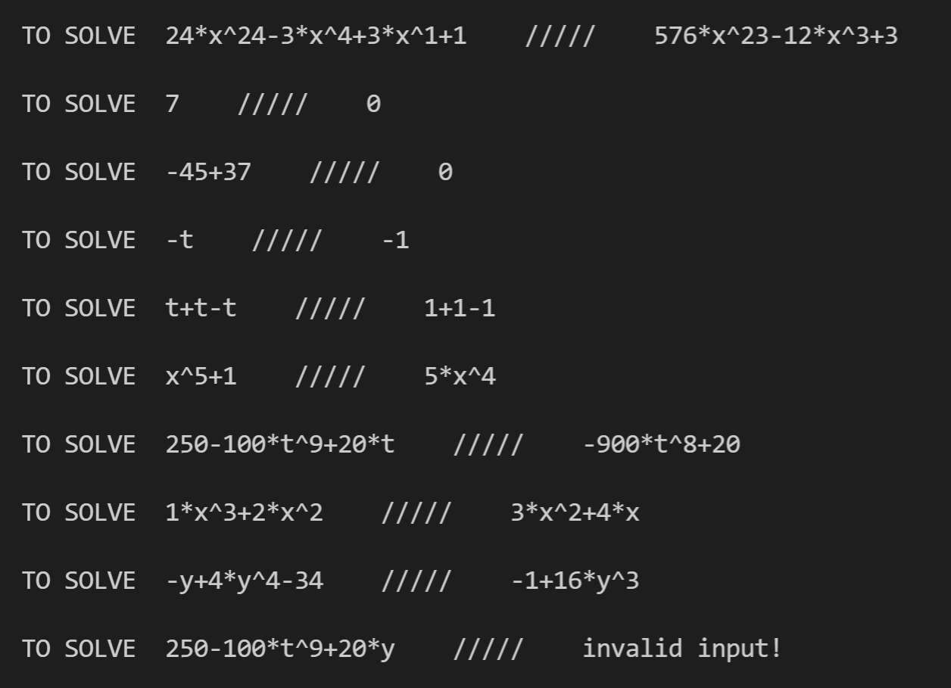

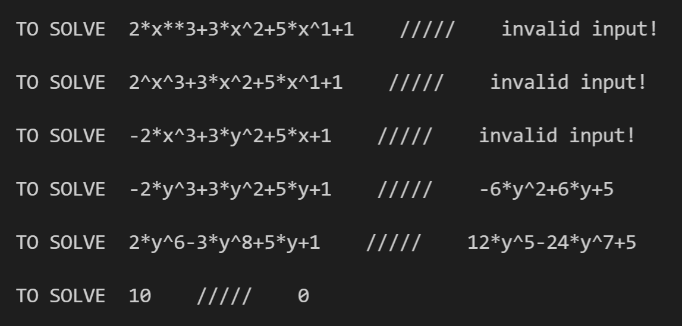

Question 3

1.This code is saved in q3.py

2.Write a Python class to simulate an ecosystem containing two types of creatures, bears and fish. The ecosystem consists of a river, which is modeled as a relatively large list. Each element of the list should be a Bear object, a Fish object, or None. In each time step, based on a random process, each animal either attempts to move into an adjacent list location or stay where it is. If two animals of the same type are about to collide in the same cell, then they stay where they are, but they create a new instance of that type of animal, which is placed in a random empty (i.e., previously None) location in the list. If a bear and a fish collide, however, then the fish dies (i.e., it disappears). Write an initializer for the ecosystem class, the initializer should allow the user to assign the initial values of the river length, the number of fishes and the number of bears. Before the simulation, fishes and bears should be allocated randomly into the river. The ecosystem class should also contain a simulation() method, which will simulate the next N steps of the random moving process. N should be inputted by the user. In each step of My simulation, all animals in the river should try to take some random moves. In each step of My simulation, the animals should take actions one by one. The animals on the left will take actions first. The newly generated animals will NOT take actions in the current step.

3.Execute as followings:

